|  |
| --- |
| **TUGAS 81 Project Cost Management** |
| **M. Hasyim Abdillah P. (1101191095) TT-42-G4** |
| Kegiatan dan anggaran biaya serta realisasi biaya dan tingkat penyelesaian sampai minggu ke 6 dari suatu proyek adalah sebagai berikut :   |  |  |  |  |  |  | | --- | --- | --- | --- | --- | --- | | Kegiatan | Waktu  (Minggu) | Kegiatan yang mendahului | Anggaran Biaya  (Rp juta) | Realisasi Biaya s/d MK 6  (Rp juta) | Tingkat Penyelesaian s/d MK 6  (%) | | A | 3 | - | 1200 | 800 | 100 | | B | 5 | - | 600 | 900 | 100 | | C | 7 | A | 350 | 210 | 100 | | D | 2 | B | 1500 | 120 | 10 | | E | 6 | C,D | 900 | 0 | 0 | | F | 4 | B | 200 | 100 | 100 | | G | 8 | B | 400 | 100 | 30 | | H | 4 | C | 800 | 0 | 0 | | I | 3 | E,F | 300 | 0 | 0 |   Bila pembebanan anggaran biaya kegiatan menggunakan aturan proporsional   1. Buatlah jaringan kerjanya (***Netwok CPM)*** , tentukan lintasan kritisnya dan hitunglah kelonggarannya (Slack Time)untuk setiap kegiatan. 2. Hitunglah anggaran dan kumulatif anggaran **(PV)** pada setiap periode perencanaan (minggu) untuk menyelesaikan proyek ini?   Berapa **BAC** (Budget At Completion) proyek ini?   1. Hitunglah pada posisi minggu ke 6 tsb : 2. PV (Plan Value) 3. EV (Earned Value) 4. AC (Actual Cost) 5. CV (*Cost Variance)* 6. SV *(Schedule Variance)* 7. CPI *(Cost Performance Index)* 8. SPI *(Schedule Performance Index)* 9. CSI *(Cost Schedule Index)* 10. ETC (Estimate cost to Completion) 11. EAC *(Estimate cost at completion)* 12. Apakah realisasi penyelesaian pekerjaan proyek lebih cepat/lambat dari rencana? 13. Apakah relalisasi biaya lebih boros/hemat dari anggaran biaya ? 14. Berapa estimasi besarnya pemborosan / penghematan biaya pada saat proyek selesai dikerjakan? |

1. Network PCM:

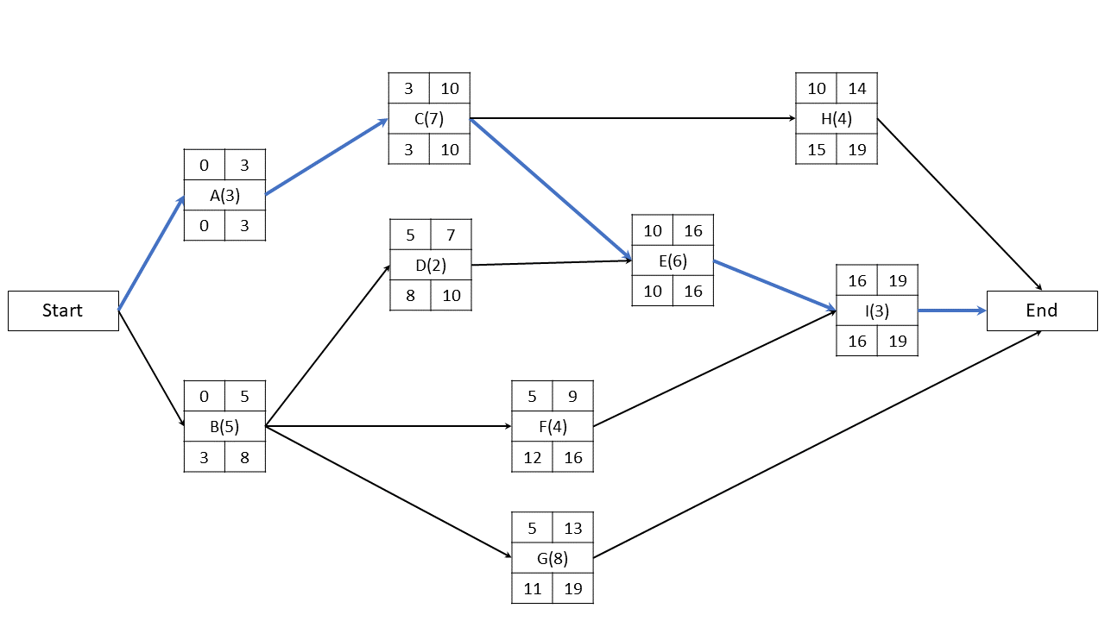

Lintasan kritis: Start – A – C – E – I – Finish

|  |  |  |  |
| --- | --- | --- | --- |
| Aktivitas | LS | ES | Slack |
| A | 0 | 0 | 0 |
| B | 3 | 0 | 3 |
| C | 3 | 3 | 0 |
| D | 8 | 5 | 3 |
| E | 10 | 10 | 0 |
| F | 12 | 5 | 7 |
| G | 11 | 5 | 6 |
| H | 15 | 10 | 5 |
| I | 16 | 16 | 0 |



|  |  |  |  |  |  |  |  |  |  |  |  |  |  |  |  |  |  |  |  |
| --- | --- | --- | --- | --- | --- | --- | --- | --- | --- | --- | --- | --- | --- | --- | --- | --- | --- | --- | --- |
| Aktivitas | Minggu | | | | | | | | | | | | | | | | | | |
| 1 | 2 | 3 | 4 | 5 | 6 | 7 | 8 | 9 | 10 | 11 | 12 | 13 | 14 | 15 | 16 | 17 | 18 | 19 |
| A | 400 | 400 | 400 |  |  |  |  |  |  |  |  |  |  |  |  |  |  |  |  |
| B | 120 | 120 | 120 | 120 | 120 |  |  |  |  |  |  |  |  |  |  |  |  |  |  |
| C |  |  |  | 50 | 50 | 50 | 50 | 50 | 50 | 50 |  |  |  |  |  |  |  |  |  |
| D |  |  |  |  |  | 750 | 750 |  |  |  |  |  |  |  |  |  |  |  |  |
| E |  |  |  |  |  |  |  |  |  |  | 150 | 150 | 150 | 150 | 150 | 150 |  |  |  |
| F |  |  |  |  |  | 50 | 50 | 50 | 50 |  |  |  |  |  |  |  |  |  |  |
| G |  |  |  |  |  | 50 | 50 | 50 | 50 | 50 | 50 | 50 | 50 |  |  |  |  |  |  |
| H |  |  |  |  |  |  |  |  |  |  | 200 | 200 | 200 | 200 |  |  |  |  |  |
| I |  |  |  |  |  |  |  |  |  |  |  |  |  |  |  |  | 100 | 100 | 100 |
| Anggaran | 520 | 520 | 520 | 170 | 170 | 900 | 900 | 150 | 150 | 100 | 400 | 400 | 400 | 350 | 150 | 150 | 100 | 100 | 100 |
| Kumulatif Anggaran (PV) | 520 | 1040 | 1560 | 1730 | 1900 | 2800 | 3700 | 3850 | 4000 | 4100 | 4500 | 4900 | 5300 | 5650 | 5800 | 5950 | 6050 | 6150 | 6250 |

BAC = Rp 6.250 juta

1. Jawaban:
2. PV = Rp 2.800 juta
3. A: 100% × 1200 = 1200

B: 100% × 600 = 600

C: 100% × 350 = 350

D: 10% × 1500 = 150

F: 100% × 200 = 200

G: 30% × 400 = 120

EV = Rp 2.620 juta

1. A = 800

B = 900

C = 210

D = 120

F = 100

G = 100

AC = Rp 2.230 juta

$CV=EV-AC=2620-2230=390$

$SV=EV-PV=2620-2800=-180$

$CPI=\frac{EV}{AC}=\frac{2620}{2230}=1,175$

$SPI=\frac{EV}{PV}=\frac{2620}{2800}=0,936$

$CSI=CPI×SPI=1,175×0,936=1,1$

$ETC=\frac{BAC-EV}{CPI}=\frac{6250-2620}{1,175}=3089,36$

$EAC=ETC+AC=3089,36+2230=5319,36$

1. Proyek lebih lambat dari rencana karena $SV<0 \& SPI<1$
2. Biaya proyek lebih hemat dari rencana karena $CV>0 \& CPI>1$

$BAC-EAC=6250-5319,36=930,64$

Estimasi penghematan biaya proyek sebesar Rp 930,64 juta